**SMART POLE – BE SMART AND SAFE**

**A Project Report Submitted for the**

**State Level Srujana Techfest 2024**

**By**

|  |  |
| --- | --- |
| HEMA SRI BANDARI | 21004-CS-094 |
| NANDINI SYAMALA | 21004-CS-068 |
| SHASHANK ATMAKUR | 21004-CS-091 |
| KAVYA BODA | 21004-CS-076 |
| GANGADHAR KODARI | 21004-CS-100 |
| UDAY BHARGAV EEKA | 21004-CS-112 |

**Under the Guidance of**

**VEMULA RAMA KRISHNA, SL/CS**

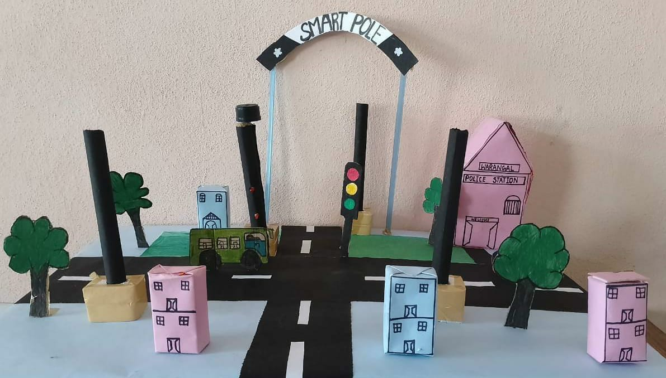

**GOVERNMENT POLYTECHNIC, WARANGAL**

DEPARTMENT OF TECHNICAL EDUCATION, TELANGANA

2024

**ACKNOWLEDGEMENT**

The success accomplishnment in this project would not have been possible, by timely help and guidence rendered by many people. We wish to express my/our sincere and heartful gratitude to all those who have helped and guided us for the completion of this project.

We earnestly thank Dr. BYRI PRABHAKAR, Principal, Government Polytechnic, Warangal, for giving timely cooperation and providing necessary resources for our project.

We express our sincere thanks and gratitude to SRI. A. RAJESHWAR RAO, Head of the Department, Department of Computer Science and Engineering, Government Polytechnic, Warangal, for this valuable help and encouragement throughout the project.

We express our sincere thanks to SRI. V. RAMA KRISHNA, Senior Lecturer in Computer Science and Engineering for his valuable guidance, provoking discussions, suggestions and sharing his valuable experties throughout the project work.

We would also thank all the staff of the Department of Computer Science and Engineering who have helped us directly or indirectly for the successful completion of the project.

Team

Smart Pole

**ABSTRACT**

This project introduces a novel approach to enhancing women's safety in urban environments through the implementation of a Smart Pole system. Traditional safety methods like relying on police response and personal devices face challenges such as slow responses and inadequate alert systems.

The Smart Pole system integrates advanced technologies including a panic button, loud siren, emergency lighting, and automated alert system to provide a quick and effective response to potential threats. Upon activation, the system triggers a multi-faceted response, alerting the nearest police station with precise location information while drawing attention with the siren and illuminating the area with emergency lighting.

By strategically placing these Smart Poles in urban areas and remote areas, this project aims to contribute to fostering a safer environment for women.

**INDEX**

**CONTENTS PAGE No.**

1. Introduction 1
   1. Project Profile and scope
   2. Existing System
2. Aim of the project 2
   1. Benefits of the project
   2. Importance of the project
3. Components used 3
4. System work flow 4
5. Project design and example uses 5
6. Output of Project 6
7. Explanation of output of the project & estimation of cost 7

Conclusion

1. **INTRODUCTION**

**1.1 PROJECT PROFILE AND SCOPE**

This project introduces a novel approach to enhancing women’s,rural safety through a smart technology known as SMART POLE.

Smart Poles are upgraded street lamps equipped with advanced features like responsive lighting, surveillance cameras, and improved connectivity.

**1.2 Existing System:**

In the current landscape, emergency situations often prompt individuals dial emergency services like 100 for assistance. While street lights are a staple in urban environments, their traditional role is limited to providing illumination. Unfortunately, this setup lacks the immediacy required to rescue people in distress. Calling emergency services relies on verbal communication, causing delays in response times, and the static nature of street lights does little to actively intervene in emergencies.

**Limitations of the existing system:**

It includes delay in response times, dependence on verbal communication, and a lack of proactive measures to address emergencies. The Smart Pole Project emerges as a transformative solution, addressing these limitations by integrating real-time communication and location-sharing capabilities directly into the urban infrastructure.

1. **AIM OF THE PROJECT**

The "Smart Pole" project aims to create a comprehensive system that leverages smart poles equipped with advanced technology to enhance public safety, particularly for individuals facing threats or emergencies. The project integrates various features, including distress button activation, voice commands, and audio/video confirmation, to provide a holistic solution for rapid response and assistance.

**2.1 BENEFITS OF PROJECT**

* Enhanced public safety through quick and efficient distress alert mechanisms.
* Empowerment of users to seek help in threatening situations.
* Real-time communication facilitates faster response from emergency services.
* Utilization of renewable energy sources contributes to sustainability**.**

The Smart Pole Project is a groundbreaking initiative aiming to redefine public safety through the integration of intelligent technology into conventional street lights. Each street light is equipped with a user-friendly button that, when pressed, activates a loud siren and simultaneously sends the precise location of the pole to the nearest police station. This innovative approach seeks to revolutionize emergency response systems, providing a swift and effective means of assistance in critical situations.

**2.2 IMPORTANCE OF SMART POLE**

A smart pole with a buzzer, siren, and light is important because it helps people quickly get help if they're in trouble. If someone is attacked, they can activate the alarm, making a loud noise and turning on a bright light to attract attention. At the same time, a message is sent to the nearby police station, so they know there's a problem and can respond quickly. This makes public spaces safer by giving individuals an easy and visible way to call for help in emergencies.

**3. Components Used**

**1. Buzzer:**

A buzzer is integrated into the smart pole to create a loud and attention-grabbing sound when activated.

**2. Siren:**

The siren is employed to enhance the alert signal, ensuring it's audible over a distance.

**3**. **Lighting System:**

Bright RED LED lights are incorporated to illuminate the area when the alarm is triggered, attracting attention.

**4**. **Microcontroller (Arduino):**

An Arduino microcontroller serves as the brain of the system, managing the activation of the buzzer, siren, and lighting components.

**5**. **GPS Module:**

A GPS module is connected to the Arduino, providing real-time location data when the emergency button is pressed.

**6**. **Communication Module:**

A communication module, possibly GSM or similar technology, facilitates the transmission of emergency messages to the nearby police station.

**4. System work-flow**

**1.Emergency Button Press:**

When the emergency button is pressed, it triggers the Arduino microcontroller to initiate the emergency response sequence.

**2. Buzzer Activation:**

The buzzer is activated immediately, creating a loud noise to attract attention and alert people in the vicinity.

**3.Siren and Light Activation:**

Simultaneously, the siren is activated to enhance the alert, and bright LED lights are turned on to increase visibility in the surrounding area.

**4.GPS Location Retrieval:**

The Arduino communicates with the GPS module to retrieve the real-time location of the smart pole.

**5.Emergency Message Generation:**

A message is generated, including the location information, indicating an emergency.

**6.Communication with Police Station:**

The communication module sends the emergency message to the nearby police station, alerting them to the situation.

**7.Emergency Response:**

With the received information, the police station can quickly dispatch assistance to the precise location of the smart pole.

**5. Project design and Example uses**

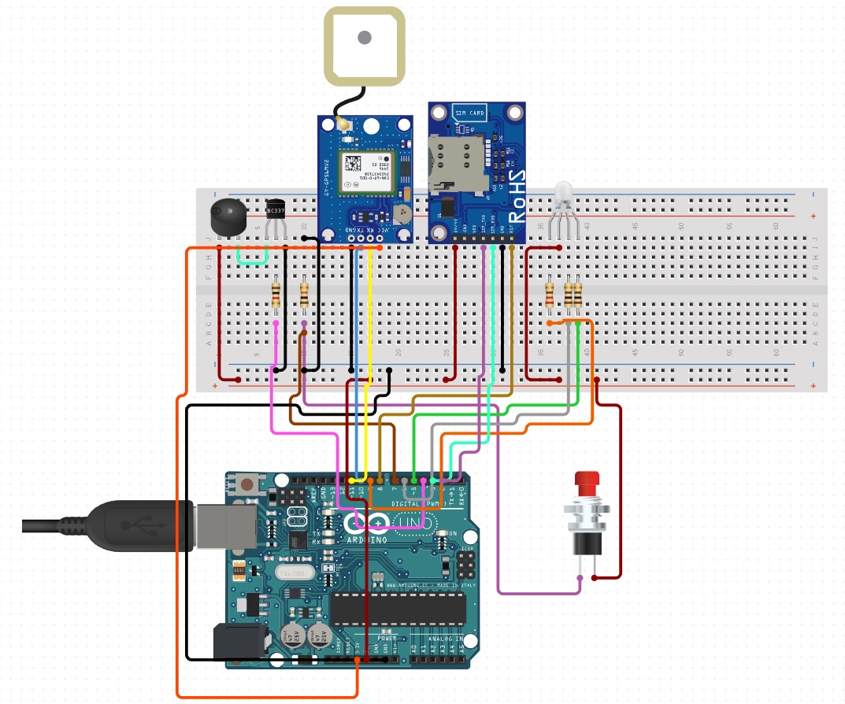

**Example Uses:**

**1. Health Emergency Response:**

Imagine an elderly person experiencing a sudden heart attack. With the Smart Pole nearby, pressing the button not only activates the siren but also sends the location to emergency services. This swift response facilitates timely medical assistance, potentially saving a life.

**2. Women's Safety Enhancement:**

In a scenario where a woman perceives a threat, a quick press of the Smart Pole button triggers the siren and alerts the police to her exact location. The integration of a camera in future iterations could also capture evidence crucial for law enforcement.

**6. Output of the project**

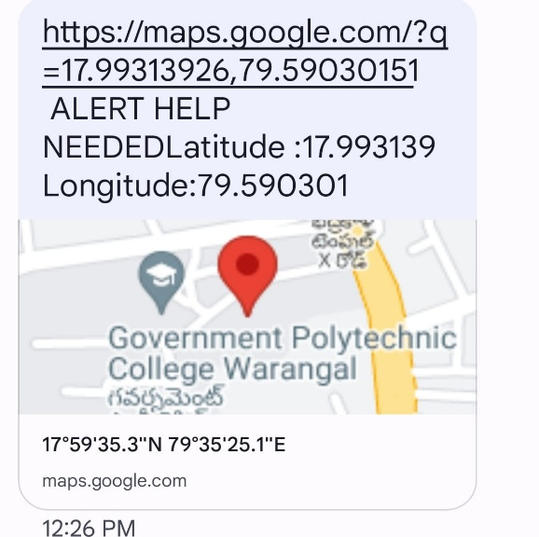

***Fig 6.1. Message alert to nearest police station***

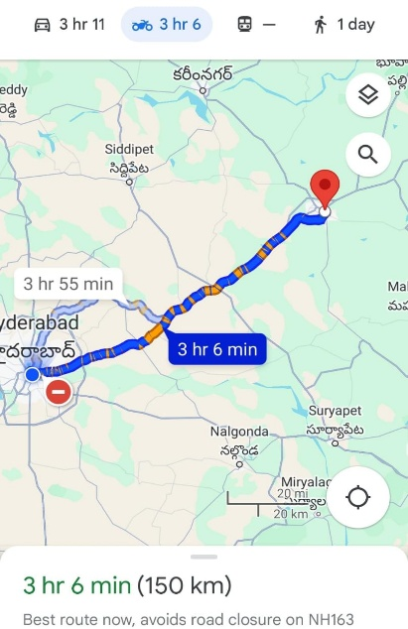

***Fig 6.2. Location of the pole***

1. **Explanation of project output**

The output screen which are presented in the previous page will give you the emergency SMS with message indicating “ALERT HELP NEEDED” and also with the coordinates of the location of the pole where the emergency situation occurs.

In Fig 6.1 the location is sent in the form of SMS to the nearest police control room when the emergency button is pressed near the pole.

In Fig 6.2 The location will give you the exact place at which pole the emergency button is pressed and the police team will take charge.

**Estimation of cost**

The cost incurred for the prototype development is as follows. As shown in the table below, it has taken approxmately Rs. 1700/- for setting up of single Smart Pole. And even further we can reduce this cost if it is implemented for Multiple pole, as the Arduino Uno, GSM modules can control multiple nearby poles, whereas we need to install separate GPS module, Buzzer and LED for individual pole.

|  |  |  |
| --- | --- | --- |
| **Sno** | **Component** | **Cost/Unit** |
| 1 | Arduino Uno R3 | ₹ 550.00 |
| 2 | Neo 6M GPS Module | ₹ 260.00 |
| 3 | GSM Module | ₹ 750.00 |
| 4 | Buzzer, Led, Cables, Bread Board | ₹ 100.00 |
|  | **TOTAL** | **₹ 1,660.00** |

It we depoloy the same prototype in realtime, approximately same cost can be incurred for components except, we need to install a Loud Buzzer and larger LED light.

Hence, this project can be economical to install in remote urban areas, where the depolyment of Mobile Patroling is difficult and to enhance the Safety of Women in those areas.

**8. CONCLUSION**

The Smart Pole Project not only addresses the shortcomings of the existing emergency response system but also pioneers a new era of urban safety. By turning street lights into active participants in emergency interventions, we envision creating a safer and more responsive environment for everyone. As we move forward, the Smart Pole Project stands as a testament to the fusion of technology and public welfare, proving that even the most ordinary elements of our urban landscape can become extraordinary agents of safety and protection.

It's like giving our city lights a superhero upgrade, turning them into active participants in keeping us safe. This project is proof that even everyday things, like street lights, can become powerful tools for our protection*.*

***It's not just about technology; it's about making our cities safer and more responsive for everyone.***

This Smart Pole Project is a small idea with a big impact, showing that even the simplest elements in our city can play a crucial role in our safety and well-being